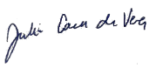

**Dr. Julius Caesar de Vera, FPCP, FPCC, FPSE**

**Lic. No. 0104858**